


Safeguarding Policy for our pupils

SAFEGUARDING? What is that?
All the adults around you think that your health, safety and wellbeing are very important. This is what we are doing to keep you safe.
What are we doing about it?
- At our school, everyone, children and adults alike, are respected and your rights are protected
- We provide a safe environment for you to learn
- The staff at our school know how to keep you and your friends safe, at home as well as school
- You can get help if you are worried or unhappy about something, either for yourself or for your friends
- We teach you to recognise risks in different situations and what to do about it
- Our lessons include, healthy eating, e-safety, road safety, open water safety, personal safety, active consent and other things we think you need to know
- We have special assemblies and visitors in school to help you be aware of keeping yourself and others safe in different situations

What can you do about something that is worrying you?
- If you need to talk to someone, Mr Dowse or Mrs Tokunaga are our Safeguarding Lead teachers, but you can talk to anyone on the staff who you can trust keep our children safe
- Put a note in the worry box in your classroom
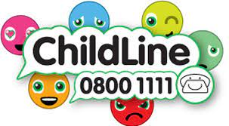
- You can also call or email ChildLine for help, or just to talk
https://www.childline.org.uk/kids/

What will happen then?
- Sometimes adults may need to speak to another member of staff for more advice then write your worry down so they can help later on
- Sometimes they may need to contact other people who support children and families. You might have seen Tracey Hawkins around school on Fridays. She is someone who works in school helping us for all sorts of reasons and she can get to know your family well
- The adults will let you know what will happen next
What if something or someone online upsets you?
- If you have a problem with something or someone online you can report it to CEOP as well as your teacher or adult at home

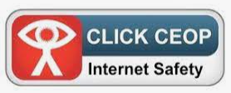
- You can get good advice about staying safe online on Childnet too
https://www.childnet.com/young-people/primary
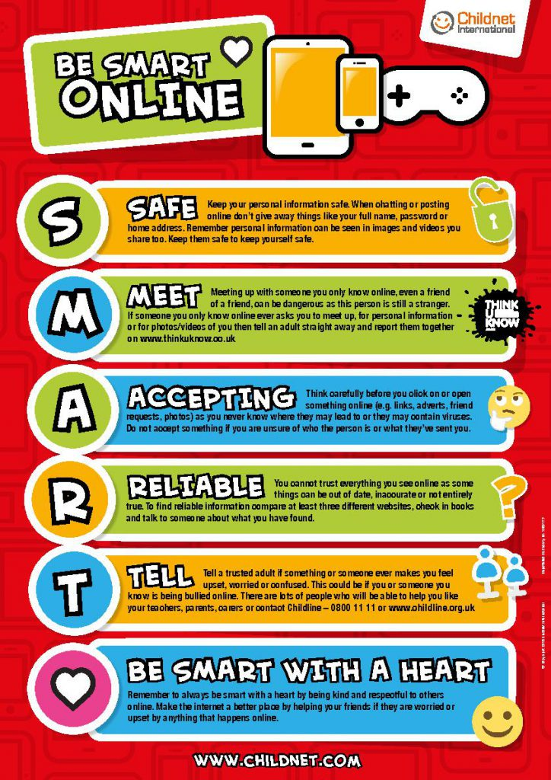

If you or your family or friends are in serious danger,
you must call the police on 999 or 112

The important thing to remember is that we are all here to guard your safety, so please share and talk about the things that are worrying you.

