

Cutthorpe Primary School
Safeguarding information for visitors

All staff and visitors alike have a responsibility for safeguarding our children. To ensure this, we ask the following:

In the event that you do need to use your mobile phone or camera enabled device, please do so in an area that is not accessed by the children. This includes the school office or staffroom.

Please ensure that you switch off your mobile phone and have it stored in an appropriate place.

If you are working with a child, please ensure that the class teacher is aware of this, where you are working and for how long.

Do not take any pictures, videos or sound recordings of any pupils unless permission has already been given.

If you are working with a child, please do so in a space that is open. Always have an open door or be visible by others through a window.

If you have a concern about a child, please pass this on to the child’s class teacher who will follow our safeguarding procedures. If they are not available, please speak to our designated safeguarding officers.

If you have a concern about another adult in school, please speak to the designated safeguarding officers.

Always share concerns with school staff, no matter how small they appear. Please do not keep them to yourself.

If a child says something that you think could be a safeguarding concern, act as above, and if possible, write down what was said immediately. Listen to the child, do not question them or promise them that it will remain confidential between the two of you.

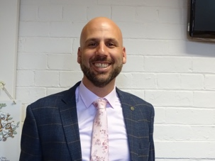 | Mr James Dowse  Headteacher and Designated Safeguarding Lead
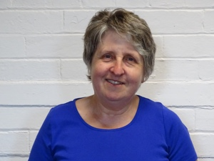 | Mrs Margaret Tokunaga  Teacher and Deputy Safeguarding Lead

Guidelines for Visitors – Fire and Emergency Evacuation Procedures

- In the event of a fire alarm, all adults and children must evacuate the building by the most direct route possible and assemble at the marked point on the playground.

- All fire exits are clearly signalled

- If you are responsible for a child, lead them quickly and quietly to the playground and to their class teacher.

- If you are unsure of the whereabouts of a child, please report this to a staff member immediately, ideally the child’s class teacher.

- Class teachers will count their class and check for any missing children against their register.

- The administrator and available TA’s will check the in/out visitor books for any missing adults.

- The headteacher will allow re-entry to the building once they have declared it safe to do so.

- If you discover a fire, the alarm should be sounded. There are ‘break glass’ fire alarms around the school.

- Do not fight the fire unless you have been trained at it is safe to do so.

- Please sign in and out and wear your visitor’s lanyard at all times.

Please return this copy of our safeguarding information to the school office before you leave.

Thank you for your support

